FORMAL ARCHIVES C.13
TIMSBURY,SOMERSET
The Formal Archives material concerning the College’s ecclesiastical patronage at Timsbury in Somerset is all coded C.13, and is contained in a single box. It was all reexamined and described afresh without rearrangement (which was and remains only partially logical) or renumbering in 2016. It is almost all in good condition. It concerns the history of the Advowson in the 17th century; its acquisition by the College in the 18th; and additions to the Rectory estate, coal mining rights and the rebuilding of the Church in the first half of the 19th.
C.13.1-C.13.1b, C.13.3, C.13.4a-c, C.13.5a-c, C.13.6a-b, C.13.7a-c. Documents dated 1797-1839 concerning property of the Flower family in Timsbury apparently adjoining the Rectory which passed in 1839 by C.13.7a (which recites the history of the property) from Jacob Flower Yeoman of Timsbury and Charlotte his wife to the College. In previous very brief listings, three documents were overlooked. These have now been numbered according to where they were found: C.13.1a, C.13.1b (found interleaved with C.13.1,1797) and C.13.7c*(found interleaved with C.13.7c,a receipt by Jacob Flower dated 17 July 1839 to Mr Simmons for rent due from the Rector of Timsbury).
C.13.2. Probate copy and probate certificate for the Will of John Flower Yeoman of Timsbury, which was made 14 November 1788 and proved by Ann Flower his widow in the Consistory Court of the Bishop of Bath and Wells 17 June 1784.
C.13.8. ”The coppy of a Terrier…..” of the property and tithes of the “parsonage of Timsborough” made by Alexander Agasman, Rector and others 16 August 1634. A very detailed description is given. A contemporary or near contemporary copy.
C.13.8b. A full modern transcript of C.13.8. No C.13.8a is present.
C.13.9. Conveyance of Timsbury Advowson by Thomas Samborne Esg of Timsbury (son of the late Mawdley Samborne) to Richard Kidder Bishop of Bath and Wells, 9 February 1698.Torn and soiled at some folds but complete with intact seal attached (small circular showing a three masted ship). See C.13.17 for Samborne’s bond of the same date.
C.13.10. The Will of Thomas Deeke Gentleman of Timsbury ( attested copy dated 2 March 1805) made by him 25 January 1759, The place and date of probate are not indicated, but C.13.15 states that this Will was proved at Wells soon after the testator’s death in May 1763.

C.13.11. Receipt and Certificate “No.231 Somerset” from the Commissioners of the Land Revenue to the Revd William Brudenell Barter Rector of “Timsbury otherwise Timsborough” for £22.10s, redeeming in perpetuity the annual rent charge of 18s in respect of the Rectory estate “heretofore payable by William Fernyhough”, 28 March 1787.

C.13.12 and C.13.15. Deeds dated 25 and 26 March respectively, 1805, whereby two pieces of land in Purlitch Field Timsbury which adjoined or were surrounded by the Rectory estate were conveyed by the Revd Brouncker Thring DD of Sutton Deny Wiltshire and the Revd Bartholemew Deeke Smith of Bradford Wiltshire to the Revd William Brudenell Barter.

C.13.13 and C.13.14. Deeds dated 7 and 8 June respectively 1820 whereby the Revd William Brudenell Barter conveyed the two pieces of land in C.13.12 and C.13.15 to the College.

C.13.16. A list in a 17th century hand of Rectors presented to Timsbury and by whom, 1625-1689.

C,13.17. Thomas Samborne’s bond concerning C.13.9, of the same date.

C.13.18. Draft on paper for C.13.19.

C.13.19. Richard Kidder, Bishop of Bath and Wells, to the College, gift (“in Consideration of the good order Discipline and Government now exercised in the said Colledge”), in the form of an Indenture Tripartite, of the Advowson of Timsbury, after the decease of Sir Anthony Deane of St Andrew Holbourne Middlesex, on condition of the College always presenting a Rector who would actually reside at Timsbury, a £500 obligation bond being executed to ensure that. Dated 19 September 1701. Signed “Richard Wells” and cut for a seal tags, but no seal tags or seals are present, and no other signature appears. Endorsed to the effect that the sole signature was witnessed by Wm Brydges.

C.13.20. Indenture Tripartite very similar to C.13.20 except that Sir Anthony Deane is of “Charterhouse Yard” Middlesex, and there is a different provision for enforcing residence. Dated 27 October 1701. Signed “Richard Wells” with his seal; sealed by the College with the great St Catherine seal. Not signed or sealed by Sir Anthony Deane although he is named as a party.

C.13.21. A detailed plan of Timsbury dated 1784, scale approx. 10 chains to the inch.

C.13.21a An email concerning C.13.21 from Alex Samborne (a descendant of the family which owned the Timsbury estate for many years) annotated with JHJ’s response, 2002.

C.13.22.The Revd WB Barter’s receipt from MessersThring and Phelps for £7.1.6, fees respecting C.13.13 and C.13.15, dated 25 March 1805.

C.13.23a. Memorandum in the hand of Richard Jenkyns, Master of Balliol, December 1820, concerning the lands in C.13.13 and C.13.14.

C.13.23b. A note in the hand of Richard Jenkyns, Master of Balliol concerning land contiguous toTimsbury Parsonage which was acquired in 1839. See C.13.1 etc above.

C.13.24. Copy letter, CP Ilbert, Bursar of Balliol from 2 New Square Lincolns Inn, to the Revd R Hill concerning the Rector’s mining rights at Timsbury, 5 December 1873.

C.13.25. Working list of deeds relating to Timsbury, Kilve, Bere Regis, Calstone and Duloe, 1578-1722. Mostly in the hand of Joseph Sanford, with many crossings out and 19th century annotations.

C.13.26.”Minutes of what passed at a College Meeting May 22 1794 respecting the Coal Mines under the Glebe at Timsbury” in the hand of John Parsons ,later Master of Balliol initialled by him .
C.13.27 and C.13.29. 2ALS WB Barter from Timsbury to John Parsons Master of Balliol , 23 October and 6 November 1804, concerning the purchase of two pieces of land at Timsbury.
C.13.28. Copy letter John Parsons, Master of Balliol to the Revd Mr Barter, 10 November 1804, responding to C.13.29.
C.13.30-C.13.34. Correspondence between John Parsons, Master of Balliol ,WB Barter, Rector and Richard Prosser Archdeacon of Durham, January-February 1806 concerning coal-mining at Timsbury.Two of Barter’s letters have an armorial seal in black wax :a chevron between three ? upturned bowls on a shield with a crest comprising an arm embowed in armour clutching a club or similar. Prosser’s letter has an elaborate armorial seal shown below:
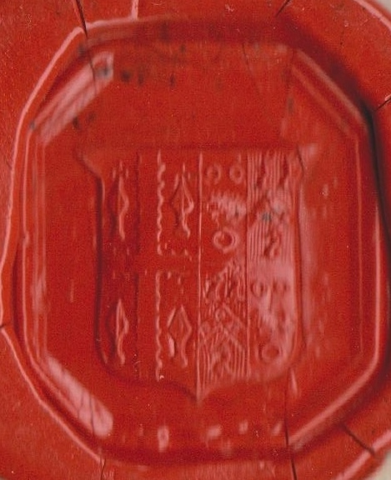
On the dexter side is an engrailed cross between four indistinct charges, perhaps spearheads with some detail at their points. On the sinister side an engrailed bar between three quoits is quartered 1 and 3 with a chevron bearing three quoits between three stags heads erased 2 and 4.
C.13.35 and C.13.36. 2ALS WB Barter to Richard Jenkyns, Master of Balliol 9 February and 13 October 1820 concerning the lands in C.13.13 and C. 13.14.
C.13.37. A Memorandum in the hand of Richard Jenkyns Master of Balliol concerning C.13.13 and C.13.14 etc , nd.
C.13.38. A dictated letter, Richard Beadon, Bishop of Bath and Wells (signing in a very shaky hand “R: Bath & Wells”) from 5 Princes Building Bath, 27 February 1820 to WB Barter concerning Barter’s gift of land to the Rectory estate.
C.13.39-C.13.41. 3ALS WB Barter to Richard Jenkyns Master of Balliol March-April 1825 concerning plans to rebuild Timsbury Church enlarged, mentioning the architect Mr Underwood.
C.13.42-C.13.47. 5ALS CTC Trelawney (CharlesTrelawney CollinsTrelawney, formerly Charles Trelawney Collins), Rector of Timsbury to Richard Jenkyns Master of Balliol , 1839 concerning purchase of land extending the Rectory estate:
C.13.42. From 2 Manchester Street London, probably 2 July 1839. Closed with the seal shown on the right below in black wax. Includes a neat sketch map of the land concerned.
C.13.43. and C.13.44. From Ham 16 and 23 April 1839, postmarked Plymouth. Closed with the seal shown on the left below.
C.13.46 and C.13.47. From Timsbury Rectory 22 October and 18 November 1839. Closed with the seal shown on the right below in red wax.
CTC Trelawney’s mother was Mary Trelawney of the Trelawney family of Ham,Devon. In 1839 he added her surname ( which he already had once as a second forename) by royal licence, as requested by her in her PCC will of 1838. In 1839 he used two seals to close his letters; perhaps this arose from the name change .
α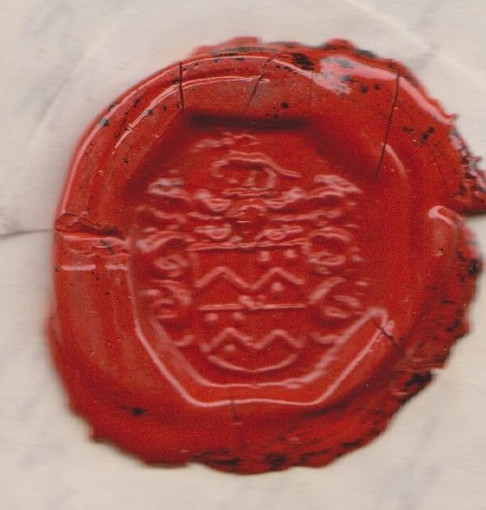 ß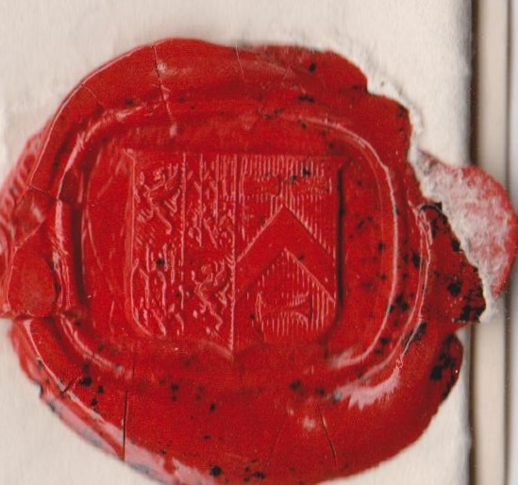
In α the shield shows a chevron quartered 1 and 3 with a chevron between three balls 2 and 4 , and there is crescent for difference at the centre. Above the shield is a helm below a beast passant, perhaps a stag.
In ß the dexter side shows a dragon rampant quartered 1 and 3 with further indistinct marshalling 2 and 4; on the sinister side is a chevron between three unrecognized rectangular charges.
C.13.45. A brief legal opinion from J Lintorn Simmons of Keynsham, 17 May 1839, concerning purchase of land extending the Rectory estate.
C.13.48. JHJ’s correspondence about Timsbury with the Revd John Reed of Timsbury Rectory, March 1990.
C.13.49. 19th century Timsbury deed bundle labels.
JHJ 13 February 2016

